

**Asset Practice Answers: Mathematics**

1. How many squares are there in the figure below?

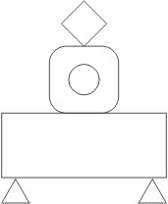

A. 0

**B. 1**

C. 2

D. 3

2. Romy is drawing a square.

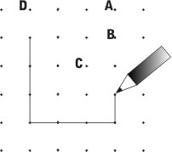

Which point will the completed square touch?

A. Point C

B. Point D

C. Point A

**D.** **Point** **B**

3. A triangle is turned as shown below.

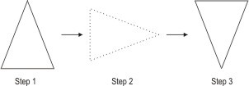

What is true about the shape formed in step 3?

**A. It will be a triangle.**

B. It will be a cone.

C. There is no name for the shape formed.

D. It will be a new shape that is NOT a triangle or a cone.

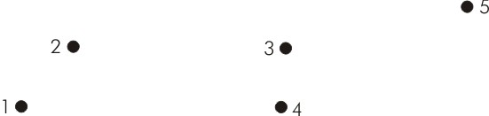4. Five dots are shown below

Which three dots can be joined with just one straight line?

A. 1, 2 and 3

**B. 1, 3 and 5**

C. 2, 4 and 5

D. 2, 3 and 5

5. How many straight lines are there in the figure shown below?



A. 2

B. 4

C. 5

**D. 6**

6. The eraser shown below is 1 unit long.

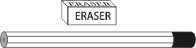

The length of the pencil can be estimated as _____

A. 2 units

**B. 4 units** C. 7 units D. 8 units

7. Hamid had a block of wood with a dot on one of its faces.

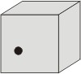

He put a dot on each of the other faces of this block. How many dots did he put?

A. 2

**B. 5**

C. 7

D. 8

8. Which of these is a square?

A. 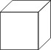 B. 

**C.** 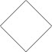 D. 

A. (A)

B. (B)

**C. (C)**

D. (D)

9. A pizza was divided into 4 equal pieces and Anand ate one of the pieces.

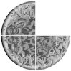

If Anand eats ONE MORE piece, what part of the pizza will remain?

A. 1/4

**B. 1/2**

C. 3/4

D. No part will remain.

10. What fraction of the figure below is shaded?

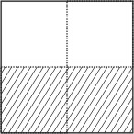

**A. 1/2**

B. 1/3

C. 2/2

D. 1/4

11. What fraction of the square is shaded?

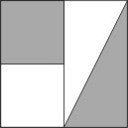

A. one

B. a quarter

**C. two quarters**

D. a quarter and a half

12. A small bowl contained some gems, 1/2 of which were red.



All the gems from this small bowl were put into an empty larger bowl. What fraction of the gems will be red in this larger bowl?

A. 1

**B. 1/2**

C. 1/4

D. 1/8



1. B: A square is made of 4 straight lines which are equal in length. So even when a square is rotated the shape still remains a square. The shape like a diamond can be obtained by turning a square. So the shape is a square. The shape shaded is not made of straight lines. It is rounded at the corners. So it is not a square.

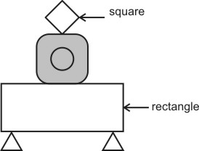

2. B: Each side of a square is equal in length. If you complete the square, point B will be at its corner as shown. Hence B is the answer.

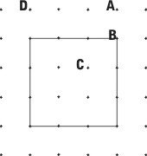

3. A: A triangle has 3 sides and 3 corners. The shape formed in step 3 has three sides and three corners. So the shape formed is a triangle. By turning a triangle, the shape still remains a triangle. A cone has a circular face. Does the shape in step 3 have a circular face? So the shape is not a cone.

4. B: Try visualizing this. If you place a ruler connecting dots 1 and 2, do you see any of the dots 3, 4 or 5 along the ruler?

Similarly if you place a ruler connecting dots 1 and 4 do you see any of the dots 2, 3 or 5 along the ruler? You can check

and see that only dots 1, 3 and 5 can be connected by a straight line drawn using a ruler. Hence B is the answer. If you connect dots 2 and 3 by a ruler you don't find dot 5 also in line.

5. D: A line which can be drawn using a ruler will be a straight line. We cannot draw curved lines using a ruler. In the given shape we can draw the two slant lines at the top using a ruler. So these lines are straight lines. The shape is made of 6 lines all of which are straight lines. Hence 6 is the answer and not 4.

6. B: From the figure we can see that the length of the given pencil is 4 times the length of the eraser. Since the length of the eraser is 1 unit, the length of the pencil is 4 units. If 7 erasers are placed next to each other along the pencil, the total length of these erasers will exceed the length of the pencil.

7. B: Take a cube or a rectangular box like a shoe box. Count each of the outer faces of the box you can touch. How many faces do you find? 6, right? Did you count the bottom face? If Hamid puts a dot on each of the other faces of the block he would be putting dots on 5 faces.

8. C: Take a square sheet of paper. Its four sides are equal. If we turn it it in any direction its shape does not change. It still has all its four sides equal. So the shape in C is a square. The shape in A is a cube. It has square faces. But the shape cannot be called as a square.

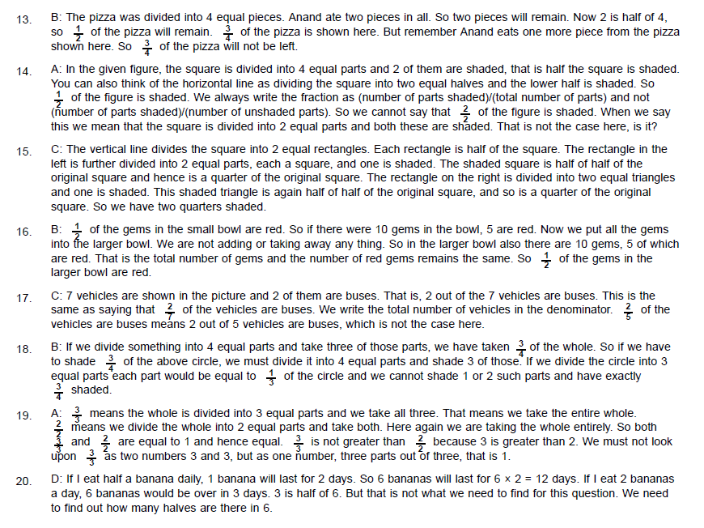

9.

10.

11.



12.